**Assignment 4.1**

df1 = data.frame(CustId = c(1:6), Product = c(rep("TV", 3), rep("Radio", 3)))

df2 = data.frame(CustId = c(2, 4, 6), State = c(rep("Texas", 2), rep("NYC", 1)))

df1 #left table

df2 #right table

For the above given data frames and tables perform the following operations:

1. Return only the rows in which the left table have match

**Solution:**

>library(dplyr)

> inner_join(df1,df2)

Joining, by = "CustId"

CustId Product State

1 2 TV Texas

2 4 Radio Texas

3 6 Radio NYC

>

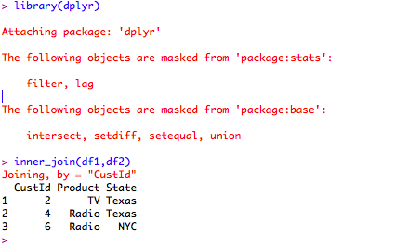

2. Return all rows from both tables, join records from the left which have matching keys in the right table.

**Solution:**

1st Method:

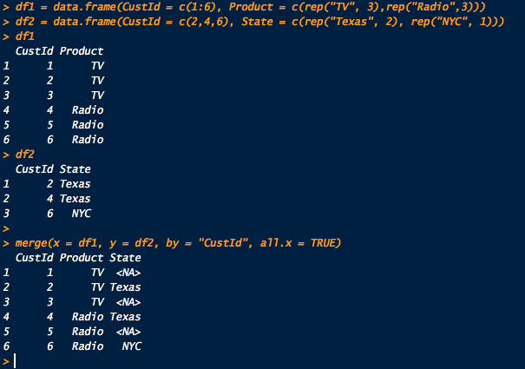

2nd Method:

